भारतमौसमविज्ञानविभाग |  | India Meteorological Department
Saturday,07th June 2025 (17 Jyeshtha 1947 Saka)
Summary of observations recorded at 0830 hours IST: The Northern Limit of Monsoon continues to pass through 17.0°N/55°E, 17.5°N/60°E, 18°N/65°E, 18.5°N/70°E, Mumbai, Ahilyanagar, Adilabad, Bhawanipatna, Puri, Sandhead Island, 23.5°N/89.5°E, Balurghat, 30°N/85°E. The upper air cyclonic circulation over northwest Rajasthan & neighbourhood at 0.9 km above m. s. l. persisted. The upper air cyclonic circulation over northwest Uttar Pradesh & neighbourhood persisted and lay at 1.5 km above m. s. l. An upper air cyclonic circulation lay over northeast Madhya Pradesh & neighbourhood and which extended upto 1.5 km above m. s. l. A trough ran from east Vidarbha to north interior Karnataka at 1.5 km above m. s. l. The trough in middle & upper tropospheric levels ran roughly along Long. 87°E to the north of Lat. 22°N. at 5.8 km above m. s. l. The upper air cyclonic circulation over northeast Assam & neighbourhood persisted and lay at 0.9 km above m. s. l. The western disturbance as a trough in middle tropospheric westerlies with its axis at 5.8 km above m. s. l. ran roughly along Long. 59°E to the north of Lat. 27°N. The trough from south Madhya Maharashtra to coastal Andhra Pradesh across north interior Karnataka and Telangana became less marked. The upper air cyclonic circulation over north interior Karnataka & neighbourhood also became less marked.
Day temperatures were appreciably above normal (3.1°C to 5.0°C) at few places over Arunachal Pradesh; at isolated places over Assam & Meghalaya, Odisha, west Uttar Pradesh, Himachal Pradesh, Jammu-Kashmir-Ladakh-Gilgit-Baltistan-Muzaffarabad, Chhattisgarh, Tamil Nadu, Puducherry & Karaikal and Kerala & Mahe. above normal (1.6°C to 3.0°C) at many places over Lakshadweep; at few places over sub Himalayan West Bengal & Sikkim, Coastal Andhra Pradesh & Yanam, coastal Karnataka and north interior Karnataka; at isolated places over Andaman & Nicobar Islands, Gangetic West Bengal, Jharkhand, east Uttar Pradesh, west Rajasthan, east Madhya Pradesh and Saurashtra & Kutch. near normal (-1.5°C to 1.5°C) at many places over Punjab, Konkan & Goa, Madhya Maharashtra, Vidarbha, Telangana, Rayalaseema and south interior Karnataka; at most places over Nagaland, Manipur, Mizoram & Tripura, Bihar and Gujarat region; at few places over Uttarakhand, Haryana-Chandigarh-Delhi, east Rajasthan, west Madhya Pradesh and Marathwada. Yesterday, the highest maximum temperature of 43.4°C was reported at Barmer (Rajasthan).
The Southwest Monsoon has been subdued over Arunachal Pradesh, Assam & Meghalaya, Telangana, Rayalaseema, Tamil Nadu, coastal Karnataka, north interior Karnataka, south interior Karnataka and Kerala.
Total 304 Station reported rainfall today. Total rainfall is 72.9 cm. Total 293 Station reported rainfall today whose normals are available. Total rainfall is 71.2 cm with normal station total is 177.1 cm.
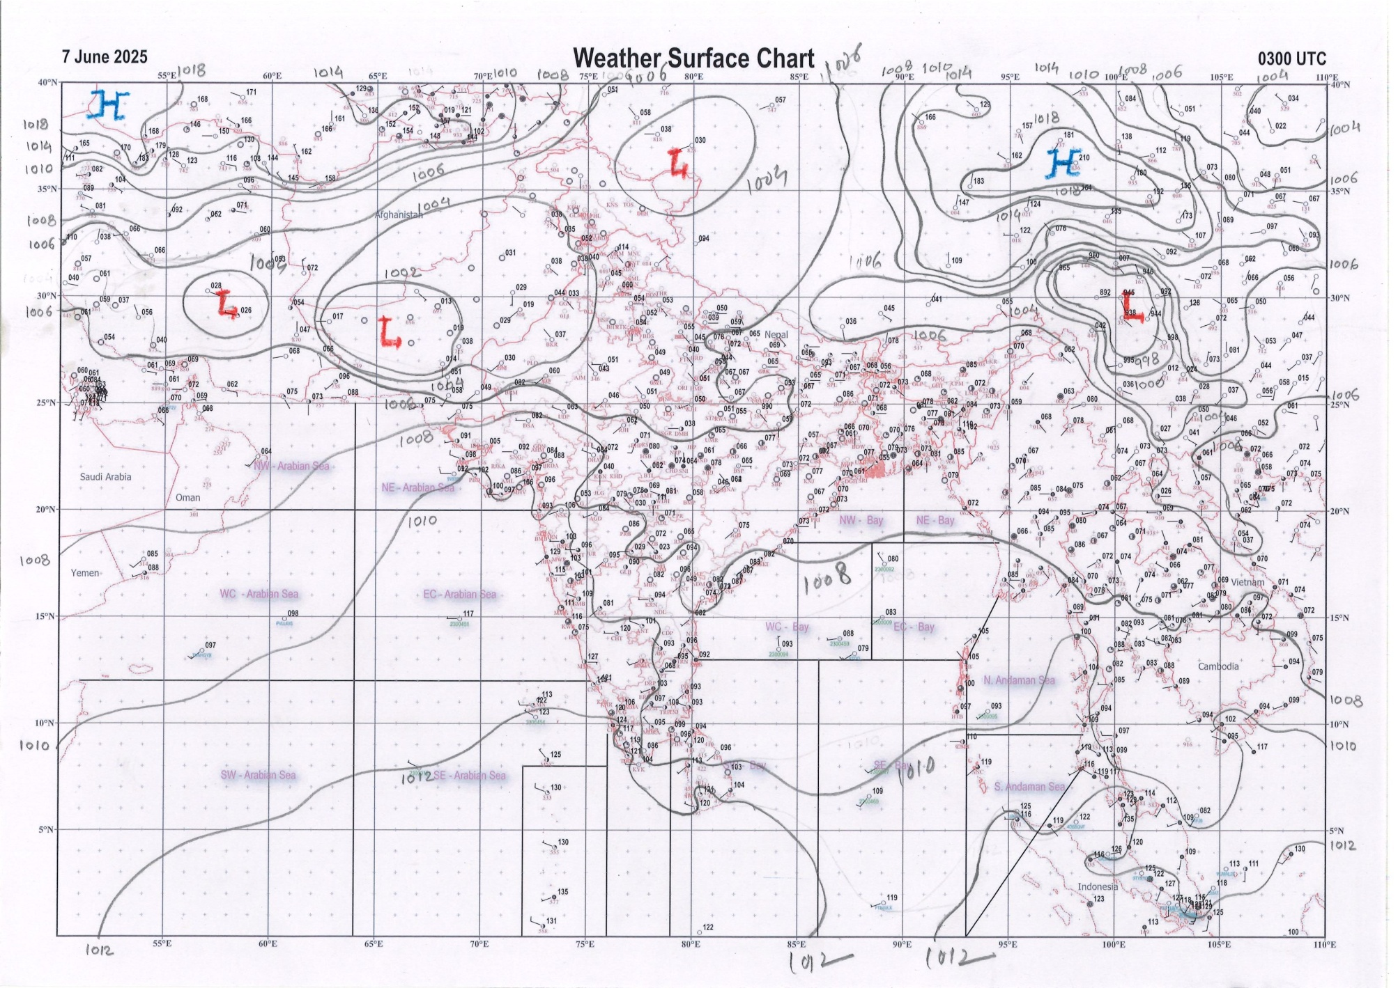 | 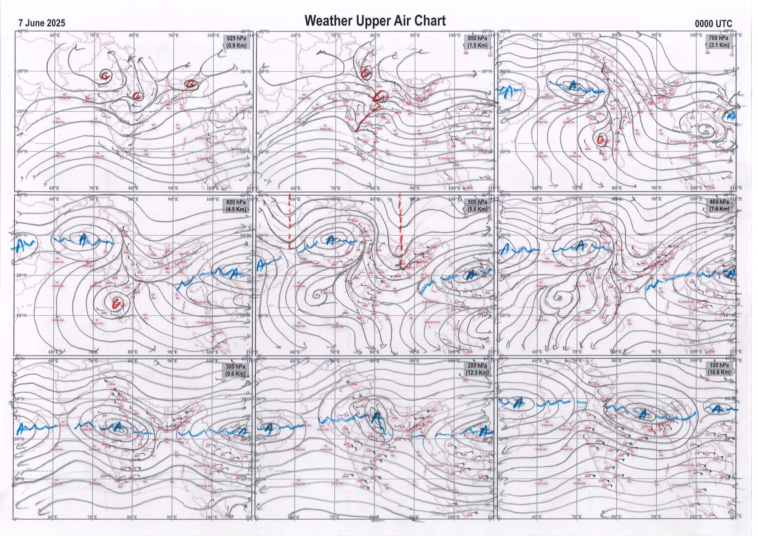
g.1. Analysed surface chart based on 03z observation | Fig.2. Analysed upper air chart based on 00z observation

Dr. Sudeep Kumar B.L.
Scientist ‘D’
CR & S Office, Pune  Issued at 1245 hrs. IST |  | Weather Forecasting Division  CR&S, Pune

Indian regions | Realised rainfall (chief amount in cm during past 24 hrs):
East | a few places: Nagaland-Manipur-Mizoram-Tripura and Gangetic West Bengal  isolated places: Arunachal Pradesh, Assam & Meghalaya, Sub-Himalayan West Bengal & Sikkim, Odisha+, Jharkhand and Bihar  Alipingal 8.7, Gosani 8.2, Chandbali 7.9, Gharmura 5.4, Teliamura ARG 4.9, Barpathar 4.5, Baltara 4.2, Kolasib ARG, Alipore, Narayanpur & Rajauli 4.1 each, Midnapore 3.5, Mo saltlake 3.4, Chalouni tea estate 3.1, Jiti t.e. 3.0, Putki dvc 2.6, Kailashahar AP 2.2, Tuting AWS 1.9, Hasimara 1.8, Tuting & Chaibasa 1.7 each, Silchar 1.1, Bhagalpur 0.3.
North | isolated places: east Uttar Pradesh, west Uttar Pradesh◆, Himachal Pradesh◆, Jammu-Kashmir and Ladakh◆ and east Rajasthan  dry weather: Uttarakhand, Haryana, Punjab and west Rajasthan  Sapotra 0.9, Chaksu 0.8, Jalalpur fmo 0.5, Bilaspur AWS & Dholpur tehsil SR 0.2 each, Bansi CWC, Pahalgam AWS & Bandipora AWS 0.1 each.
Central | isolated places: Madhya Pradesh, Vidarbha◆ and Chhattisgarh  Sausar 2.5, Nangur 2.0, Khategaon 1.8, Chanderi 1.7, Raisen-aws 0.8, Barsur 0.7, Pandhurna & Jagdalpur 0.5 each, Sagar-aws, Anjangaon & Chandur rlwy 0.1 each.
Peninsula | a few places: Konkan & Goa  isolated places: Gujarat Region◆, Saurashtra & Kutch, Madhya Maharashtra, Marathwada, coastal Andhra Pradesh, Telangana, Rayalaseema, Tamil Nadu, coastal Karnataka, north interior Karnataka, south interior Karnataka◆ and Kerala  Palasa 5.6, Mokheda fmo 5.1, Poladpur & Anakapalle 4.6 each, Satara 4.2, Wai 4.1, Santacruz 4.0, Vadia 3.2, Parkal 3.1, Pimpalgaonbaswant ARG, Nagari & Walajabad 3.0 each, Kancheepuram 2.8, Gondal 2.2, Dharashiv IMD parttime, Tuni & Kottayam 1.6 each, Castle rock & Vaikkom AWS 1.5 each, Yelburga 1.4, Gajwel, Bidar PTO & Bidar 1.2 each, Umarga 1.1, Kunnamkulam AWS 1.0, Renapur, Palasamudram & Airport madurai 0.9 each, Gokarna 0.5, Panambur 0.3, Dholka ARG & Nanipalson 0.2 each, Chintamani PTO & Agumbe emo 0.1 each.
Islands | many places: Andaman & Nicobar  dry weather: Lakshadweep  Hut bay 3.4, Nancowry 1.7, Iaf carnicobar 0.8.
Table 2. Forecast / warnings (distribution of rain / thundershowers) for 7 days (valid from time of origin upto 0830 hrs IST of next day)
Sr. No |  | Sub-division Name | Day 1 | Day 2 | Day 3 | Day 4 | Day 5 | Day 6 | Day 7 | Sr. No. | Sub-division Name | Day 1 | Day 2 | Day 3 | Day 4 | Day 5 | Day 6 | Day 7
 |  |  | 07 Jun | 08 Jun | 09 Jun | 10 Jun | 11 Jun | 12 Jun | 13 Jun |  |  | 07 Jun | 08 Jun | 09 Jun | 10 Jun | 11 Jun | 12 Jun | 13 Jun
 | 1 | Andaman Nicobar Islands | W + | W+ | W  | W  | W  | F | F | 19 | west Madhya Pradesh | I  | I  | I + | I + | I | I | I
 | 2 | Arunachal Pradesh | S | S | S | F +  | F +  | F + | F + | 20 | east Madhya Pradesh | I  | I  | I + | I + | I | I | I
 | 3 | Assam-Meghalaya | S  | I  | S  | S +  | F +  | F + | F + | 21 | Gujarat region | I | I | I | I | I | I | I
 | 4 | Nagaland-Manipur-Mizoram-Tripura | F +  | F  | F | F  | F +  | F + | F + | 22 | Saurashtra and Kutch | I | I | I | I | I | I | I
 | 5 | Sub Himalayan West Bengal/Sikkim | S | S | S | S | S | S | S | 23 | Konkan and Goa | S  | S  | S  | S | S | F+ | W+
 | 6 | Gangetic West Bengal | I | I | I | I | S  | S | S | 24 | Madhya Maharashtra | S +  | S  | I | I  | I  | S + | F +
 | 7 | Odisha | I  + | I + | I + | S  | S | S | S | 25 | Marathwada | S  | S  | I | I  | I  | S | S
 | 8 | Jharkhand | I | I | I | S  | S | S | S | 26 | Vidarbha | I  | I  | I | I | I | I | I
 | 9 | Bihar | I | I | I  | S  | S  | S + | S + | 27 | Chhattisgarh | I  | I  | I  | I  | I  | I | I
 | 10 | east Uttar Pradesh | D | D | D + | D + | I  | S+ | S+ | 28 | Coastal Andhra Pradesh and Yanam | I+ | I+ | I  | S  | S+ | F + | S +
 | 11 | west Uttar Pradesh | D | D | D + | D + | D + | I | I | 29 | Telangana | I  | S  | S  | S  | S  | S | S
 | 12 | Uttarakhand | D | D | D | D | I  | S+ | F+ | 30 | Rayalaseema | I+ | I + | S  | S  | F+ | F + | F +
 | 13 | Haryana,Chandigarh and Delhi | D | D | D + | D + | D + | D | I | 31 | Tamil Nadu, Puducherry and Karaikal | I  + | S  + | S  | S+ | S+  | S + | I +
 | 14 | Punjab | D | D | D + | D + | D + | D | I | 32 | Coastal Karnataka | S | S | F | F | W | W++ | W++
 | 15 | Himachal Pradesh | D | D | D | D | D | I | I | 33 | North interior Karnataka | I | S | F  | F  | F +  | W++ | W++
 | 16 | Jammu-Kashmir and Ladakh | D | D | D | D | I | I | I | 34 | South interior Karnataka | I | S | F  | F  | F +  | W + | W++
 | 17 | west Rajasthan | D | D  + | D + | D  + | D + | D | D+ | 35 | Kerala and Mahe | I | S | F | W + | W+ | W + | W++
 | 18 | east Rajasthan | I | I | D | D | D | D | D | 36 | Lakshadweep | S | S | S | F | W | W | W
Legends: D = DryI = IsolatedS = ScatteredF = Fairly widespreadW = Widespread #= heavy to very heavy rain at a few places with extremely heavy rain at isolated places +++= heavy rain at a few places with very heavy rain at Isolated places ++= heavy to very heavy rainfall @=Isolated exceptionally heavy rainfall + = heavy rain ●/*= rain or snow ♦ = very light rain ≡=fog= thunderstorm with lightning =Squall / Gusty / gale / strong wind ­ =cold wave/cold day += heat wave/warm night/hot and humid weathe r=Duststorm =ground frost = Hail

Fig. 4: Districtwise warnings for five days for Maharashtra State
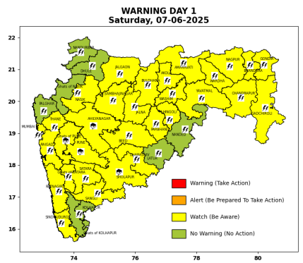 | 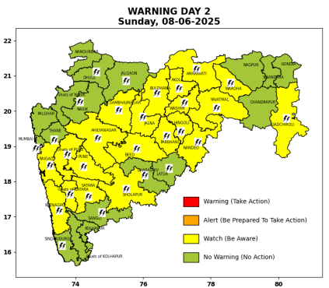 | 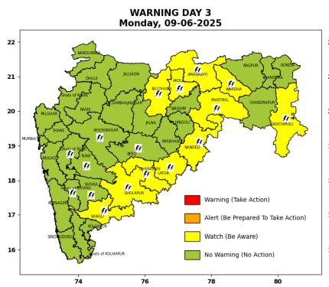 | 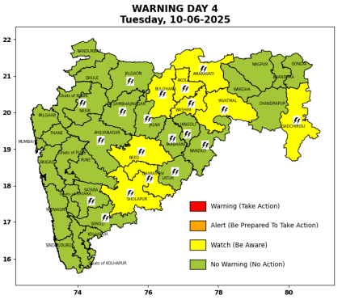 | 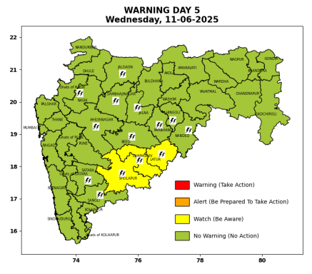

Pune, Lohegaon and Pashan observations at 0830 hrs. IST of Today
 | Temperature (°C) |  |  |  |  | Humidity (%) |  |  |  | Rainfall (mm)
 | Max.  past  24 hrs | Dep.  from  normal | Min.  past  24 hrs. | Dep.  from  normal | Dry  Bulb | At 0830 hrs. IST | Dep.  From  normal | At 1730  hrs. IST of y’day | Dep.  from  normal | Past  24 hrs. | Since  1st June | Dep.  from  normal
PNE | 33.0 | -1.3 | 22.8 | -0.6 | 26.4 | 80 | 7 | 89 | 31 | 15.2 | 33.1 | -3.5
PSN | 32.6 | - | - | - | - | - | - | 97 | - | - | - | -
LHG | 34.0 | 1.0 | 24.9 | 3.9 | 28.1 | 71 | -1 | 77 | 22 | 39.8 | 53.8 | 19.3

 |  |  |  |  |  |  | Local (Pune and neighbourhood) forecast
Max./Min. Temperature (°C) |  |  |  |  |  |  |  |  | Weather
Date | Pune | Pashan | Lohegaon | Chinchwad | Lavale | Magarpatta | NDA | Koregoan Park
07/06/25 | 29/22.8* | 28/-- | 32/24.9* | 29/24.1* | 26/-- | 30/24.8* | 27/22.2* | 29/24.6* | Partly cloudy sky becoming generally cloudy sky towards afternoon/evening. Thunderstorm with lightning, light to moderate rain very likely.
08/06/25 | 30/22 | 30/21 | 31/24 | 29/24 | 28/21 | 32/24 | 29/22 | 30/24 | Partly cloudy sky becoming generally cloudy sky towards afternoon/evening. Thunderstorm with lightning, light to moderate rain very likely.
09/06/25 | 32/23 | 32/22 | 33/25 | 31/25 | 30/22 | 33/25 | 31/23 | 32/25 | Partly cloudy sky becoming generally cloudy sky towards afternoon/evening. Very light to light rain very likely.
10/06/25 | 32/23 | 32/22 | 33/25 | 31/25 | 30/22 | 33/25 | 31/23 | 32/25 | Partly cloudy sky becoming generally cloudy sky towards afternoon/evening. Very light to light rain very likely.
11/06/25 | 32/23 | 32/22 | 33/25 | 31/25 | 30/22 | 33/25 | 31/23 | 32/25 | Partly cloudy sky becoming generally cloudy sky towards afternoon/evening. Very light to light rain very likely.
12/06/25 | 30/22 | 30/21 | 31/24 | 29/24 | 28/21 | 31/24 | 29/22 | 30/24 | Partly cloudy sky becoming generally cloudy sky towards afternoon/evening. light to moderate rain likely.
13/06/25 | 30/22 | 30/21 | 31/24 | 29/24 | 28/21 | 31/24 | 29/22 | 30/24 | Partly cloudy sky becoming generally cloudy sky towards afternoon/evening. light to moderate rain likely.
Rainfall Distribution |  |  | Rainfall Categories | Rainfall (mm) |  | Cloud condition |  |  |  | Rainfall Intensity |  | Range
Widespread (W) | 76-100% |  | Very Light rain | Trace to 2.4 mm |  | Mainly clear sky |  | 1-2 oktas |  | Light Spell |  | 1 cm/hr
 |  |  | Light rain | 2.5 to 15.5 mm |  | Partly cloudy sky |  | 3-4 oktas |  | Moderate Spell |  | 1-2 cm/hr
Fairly Widespread (FW) | 51 – 75% |  | Moderate rain | 15.6 to 64.4 mm |  | Generally cloudy sky |  | 5-7 oktas |  | Intense Spell |  | 2-3 cm/hr
Scattered (S) | 26 – 50% |  | Heavy rain | 64.5 to 115.5 mm |  | Overcast |  | 8 oktas |  | Very Intense Spell |  | 3-5 cm/hr
isolated (I) | 1 – 25% |  | Very heavy rain | 115.6 to 204.4 mm |  |  |  |  |  | Extremely Intense Spell |  | 5-10 cm/hr
D (D) | No Rain |  | Extremely heavy rain | ≥ 204.5 mm |  |  |  |  |  | Cloudburst |  | > 10 cm/hr
Probability Terms in %: |  |  | Heavy snow | 6.5 to 11.5 cms water equivalent of rain
unlikely | < 25 |  | Very heavy snow | 11.6 to 20.4 cms water equivalent of rain
likely | between 25 50
very likely | between 51 75
most likely | >75
* = realized temperature
Mumbai (Colaba) |  |  |  | Nagpur (AP)
Date 2025 | T max °C | T min °C | Weather | T max °C | T min °C | Weather
07/06 | 33 | 26 | Partly cloudy sky with possibility of moderate rain or Thunderstorm accompanied with lightning & gusty winds(30-40kmph). | 41 | 28 | Rain or Thunderstorm accompanied with lightning & gusty winds(30-40kmph).
08/06 | 32 | 26 | Partly cloudy sky with one or two spells of rain or thundershowers. | 41 | 28 | Partly cloudy sky towards afternoon or evening.
09/06 | 32 | 27 | Generally cloudy sky with light rain. | 43 | 28 | Partly cloudy sky towards afternoon or evening.
10/06 | 32 | 27 | Generally cloudy sky with light rain. | 43 | 28 | Partly cloudy sky towards afternoon or evening.
11/06 | 32 | 27 | Generally cloudy sky with moderate rain | 43 | 28 | Rain or thundershowers would occur towards afternoon or evening.
12/06 | 32 | 27 | Rain. | 40 | 27 | Partly cloudy sky with possibility of rain or Thunderstorm.
13/06 | 32 | 27 | Rain. | 40 | 26 | Partly cloudy sky with possibility of rain or Thunderstorm.

